Section: Non Verbal Reasoning - Figures

Image : 1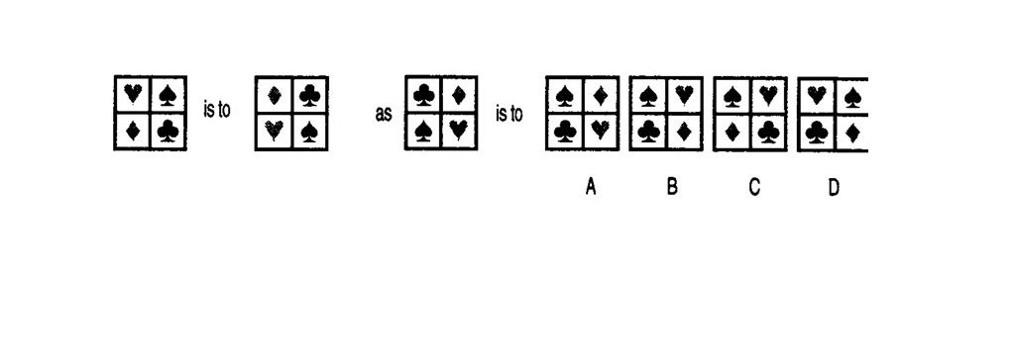Please refer Image 1 for the next question
Choose the correct option.

Q.1

A: A | B: B | C: C | D: D | E: E
Image : 2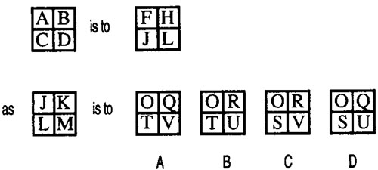Please refer Image 2 for the next question
Choose the correct option.

Q.2

A: A | B: B | C: C | D: D | E: E
Image : 3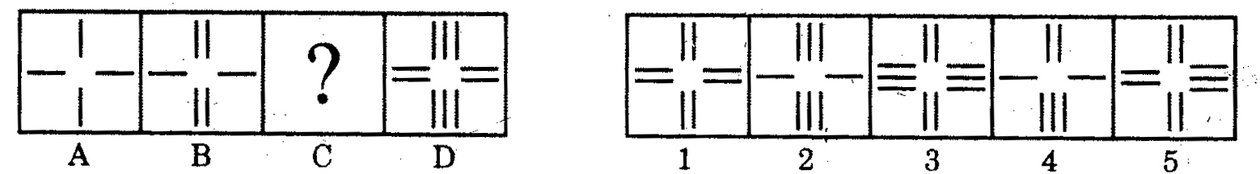Please refer Image 3 for the next question
Directions : In each of the following questions, there is a set of four figures labelled A, B, C and D called the Problem Set followed by a set of five other figures labelled 1, 2, 3, 4, and 5 called Answer Set. Figure (C) contains a question mark. Select a suitable figure from the Answer set which will substitute this question mark so that a series is formed by the figures A, B, C, and D taken in order. The number of the selected figure is the answer.

Q.3

A: 1 | B: 2 | C: 3 | D: 4 | E: 5
Image : 4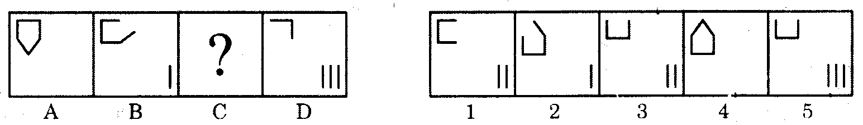Please refer Image 4 for the next question
Directions : In each of the following questions, there is a set of four figures labelled A, B, C and D called the Problem Set followed by a set of five other figures labelled 1, 2, 3, 4, and 5 called Answer Set. Figure (C) contains a question mark. Select a suitable figure from the Answer set which will substitute this question mark so that a series is formed by the figures A, B, C, and D taken in order. The number of the selected figure is the answer.

Q.4

A: 1 | B: 2 | C: 3 | D: 4 | E: 5
Image : 5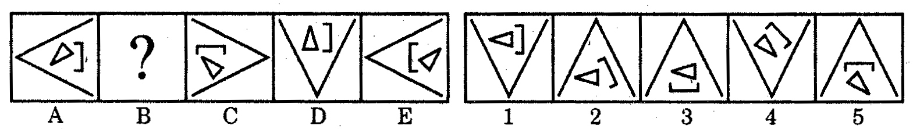Please refer Image 5 for the next question
Directions : In each of the following questions, there is a set of four figures labelled A, B, C and D called the Problem Set followed by a set of five other figures labelled 1, 2, 3, 4, and 5 called Answer Set. Figure (C) contains a question mark. Select a suitable figure from the Answer set which will substitute this question mark so that a series is formed by the figures A, B, C, and D taken in order. The number of the selected figure is the answer.

Q.5

A: 1 | B: 2 | C: 3 | D: 4 | E: 5

